Glocal Ventures, Inc. (GVI) is a humanitarian organization dedicated to holistic, socio-economic development in Vietnam. GVI mobilizes volunteers from around the world to partner with communities in Vietnam to see dreams realized and lives transformed. Volunteers serve alongside communities to help people work together in interdependency, taking charge of their situations and moving towards a more empowered and satisfying life as individuals and community.

PROPOSAL: COMPUTER LAP PROJECT
BAN PHUNG MIDDLE SCHOOL, SAPA, VIETNAM

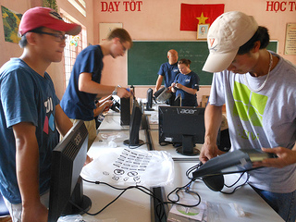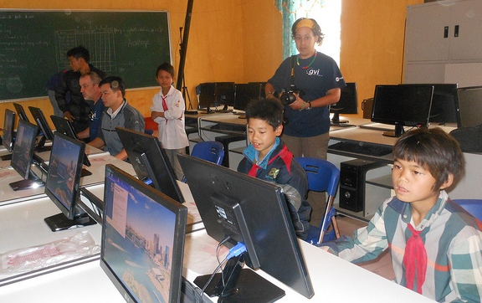

PROGRAM OVERVIEW
GVI and dedicated volunteers strive to improve the quality of education in Vietnam through the use of technology. Over the years, GVI volunteers have installed computer labs in schools and community centers giving children and teachers the opportunity to enhance learning. GVI is currently seeking support to install a new computer lab at Ban Phuong Middle School located in Sapa, Vietnam.
SCHOOL OVERVIEW
OBJECTIVES
Through the establishment of a new computer lab, the program provides economically disadvantaged children at Ban Phung Middle School in Northern Vietnam with practical training in computer literacy to give them a chance to experience the world and better their future. Moreover, the program also aims at improving the quality of education in Vietnam by integrating technology into schools and by training teachers how to leverage the use of technology as a tool in their classrooms. Specifically, the program will:
- Provide computer access and training to all students grades_____
- Provide the implementation of computer base curriculum.
- Provide internet access for homework research.
- Teach students how to conduct Internet research.
- Teach students proficiency in Microsoft Office & Google Docs.
- Teach students typing technique.
- Provide educational games to students, including Math, ESL, Art, etc.
COMPUTER LAB
The new computer lab will be equipped with 20 new computers, desks and chairs, cable networking and computer accessories. Each computer is uploaded with Microsoft Office software. Teacher training is provided to ensure the teachers are equipped with the necessary skills to transfer knowledge to their students.
Financial requirement: $20,000

BUDGET BREAKDOWN
The initial set-up costs of the Computer Lap are one-time expenses. We anticipate that this equipment will meet the program needs for at least three years.
ITEM | DESCRIPTION/QUANTITY | TOTAL COST
Computers | PC Desktop/ 20 | ???
Printer with Scanner | How many? | ???
Software | Which software? How many users? | ???
Educational Software | (Still researching options)/ How many users? | ???
Misc. Equipment | Mice, mouse pads, printer ink, ect. | ???
TOTAL |  | ???

GVI is a registered 501c (3) non-profit organization based in Keller, Texas (in the Dallas-Fort Worth area) and has a representative office in Hanoi, Vietnam that is recognized by the Vietnamese government as an international non-governmental organization (INGO).

